

**Bank system**

Dr. Mohamed Hashim



**Name: Salma EL-sayed Borham.**

**ID:17105510**

**TA: ALAA Mahmoud.**

**Feature of the web site: -**

* **The web Site Allows you users to sign up with their (Username, first name, last name, password, E-mail, and Phone Number).**
* **The web Site have the potential to add the user.**
* **The web Site have the potential to delete the user.**
* **The web Site allows the user to deposit money.**
* **The web Site Allow withdraw money.**
* **The web Site Allow Transfer Money from One User’s Accounts to Another’s.**
* **The web Site can Show the User the details of the last perform Transaction.**

* **The web Site Appear the username of the customer.**
* **The web Site Appear the balance of the user.**
* **The User Logs onto the website using the account number and password.**

* **Show an error message when enter username or password incorrect.**

**Screenshots: -**

1. **Homepage:**

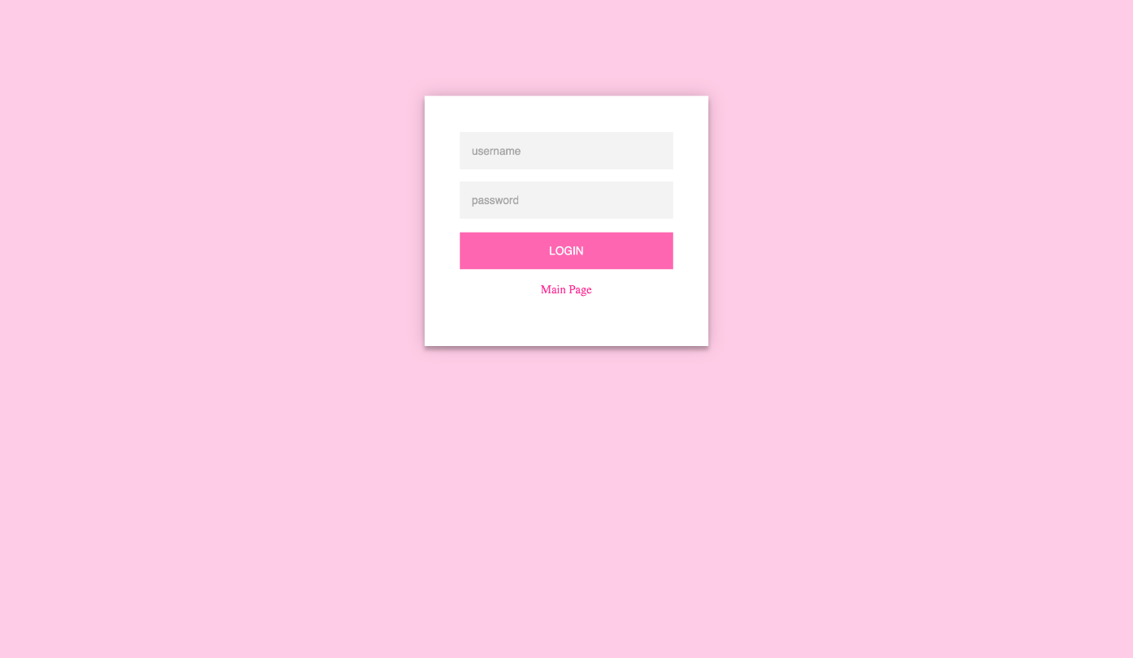**2-Login:**

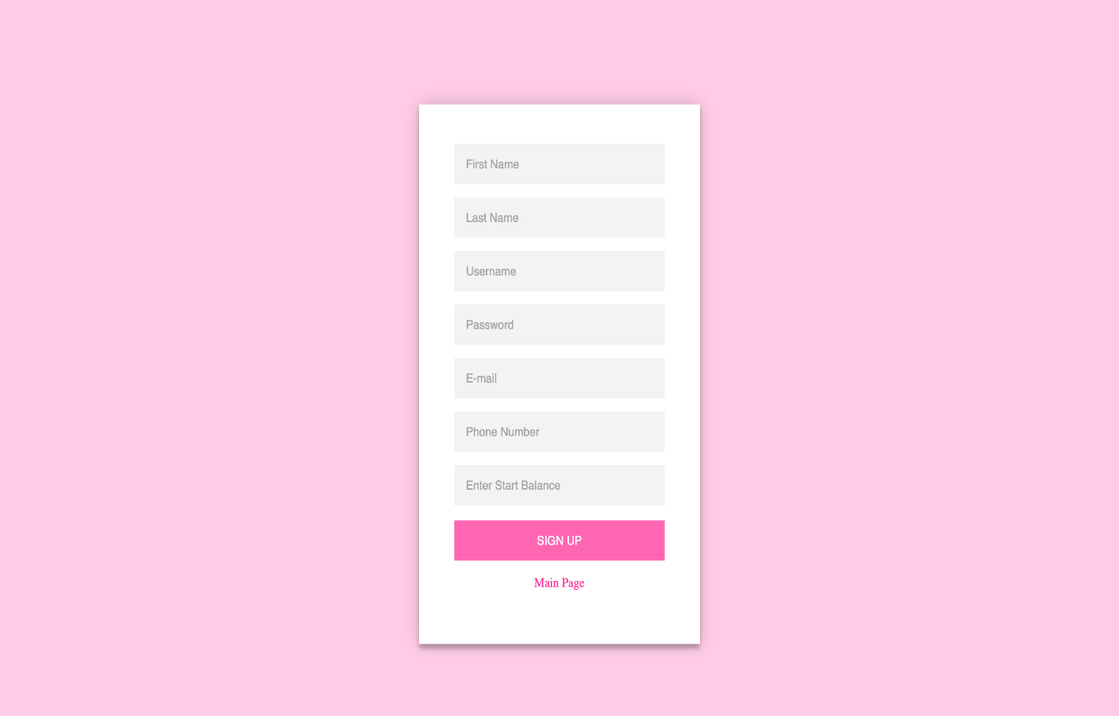 **3-sign up:**

**4-Proccess:** 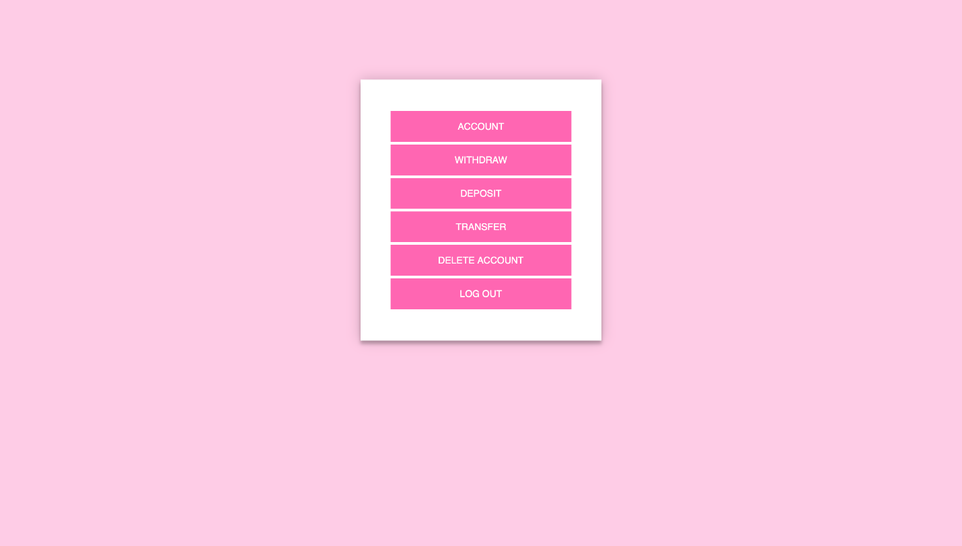

**5-Account Information:**

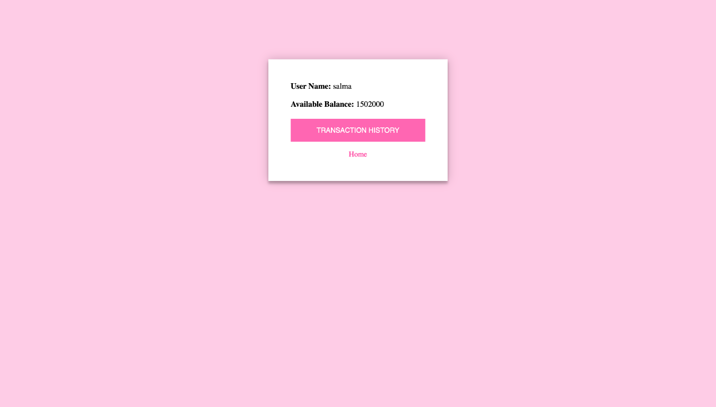

**6-Transaction History:**

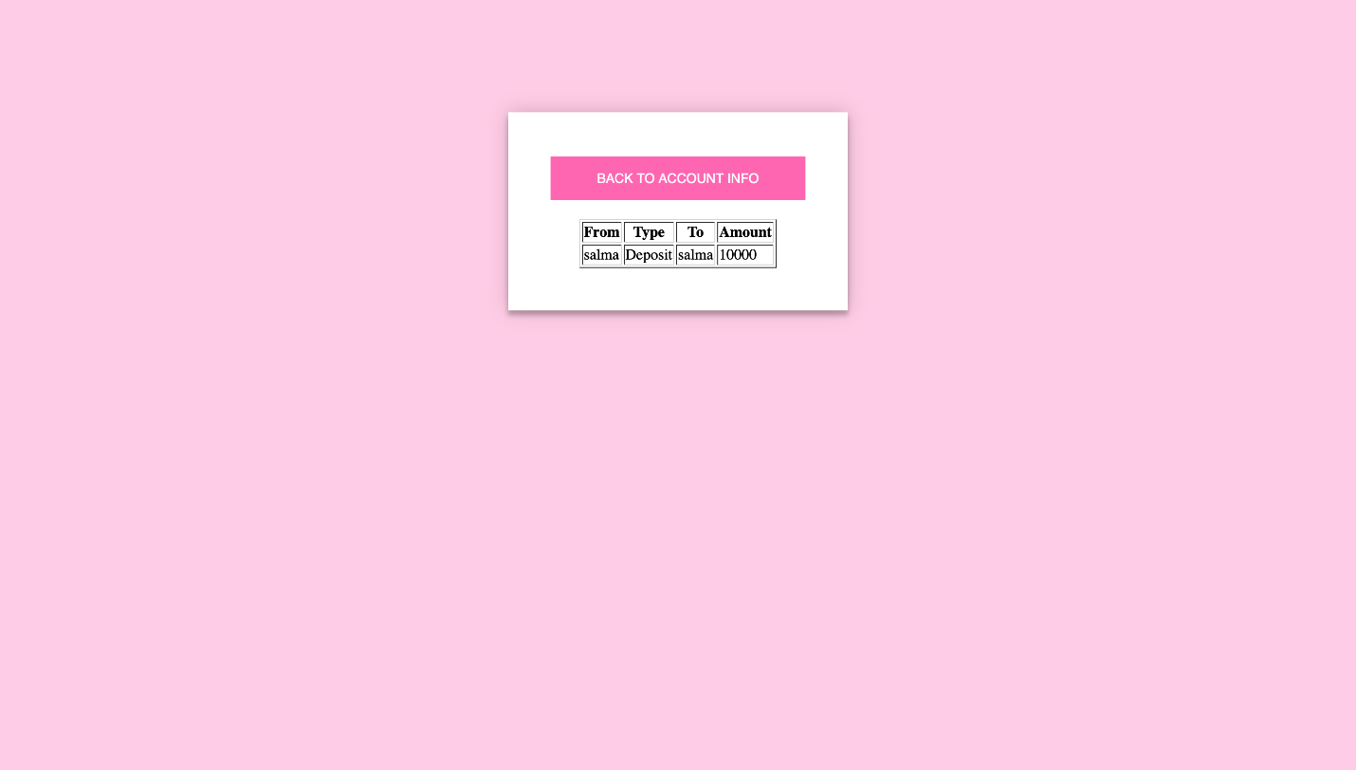

**7­-Withdraw:**

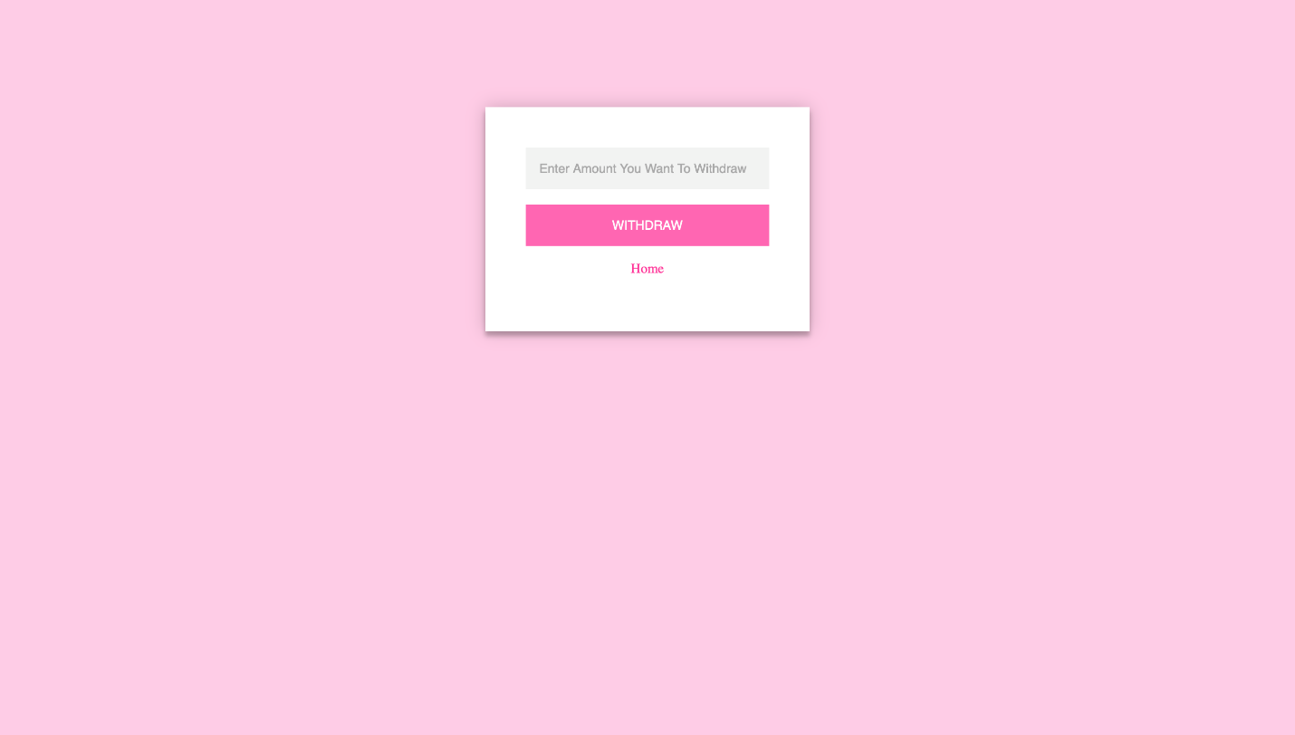

**8-Deposit:**

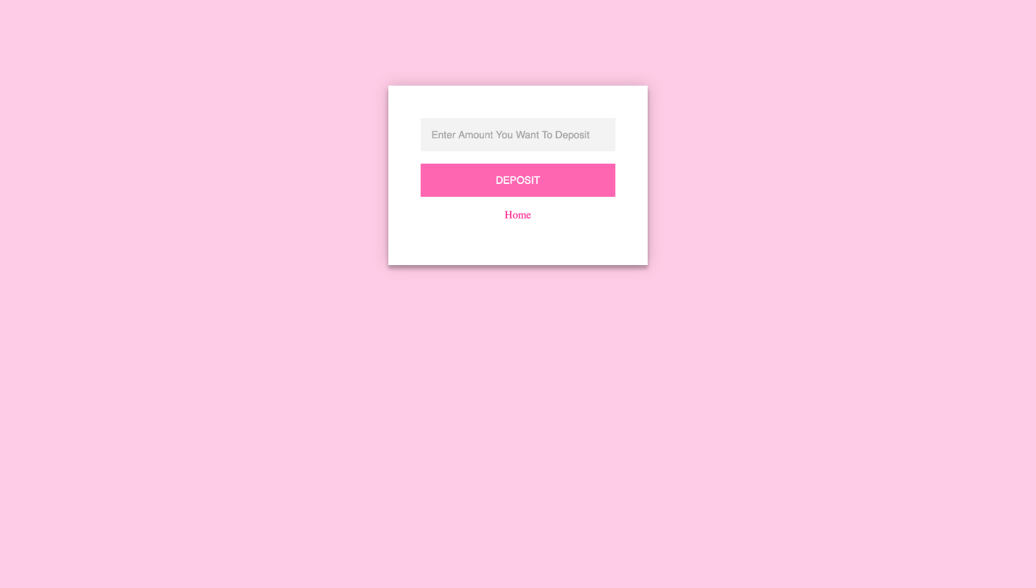

**9-Transfer:**

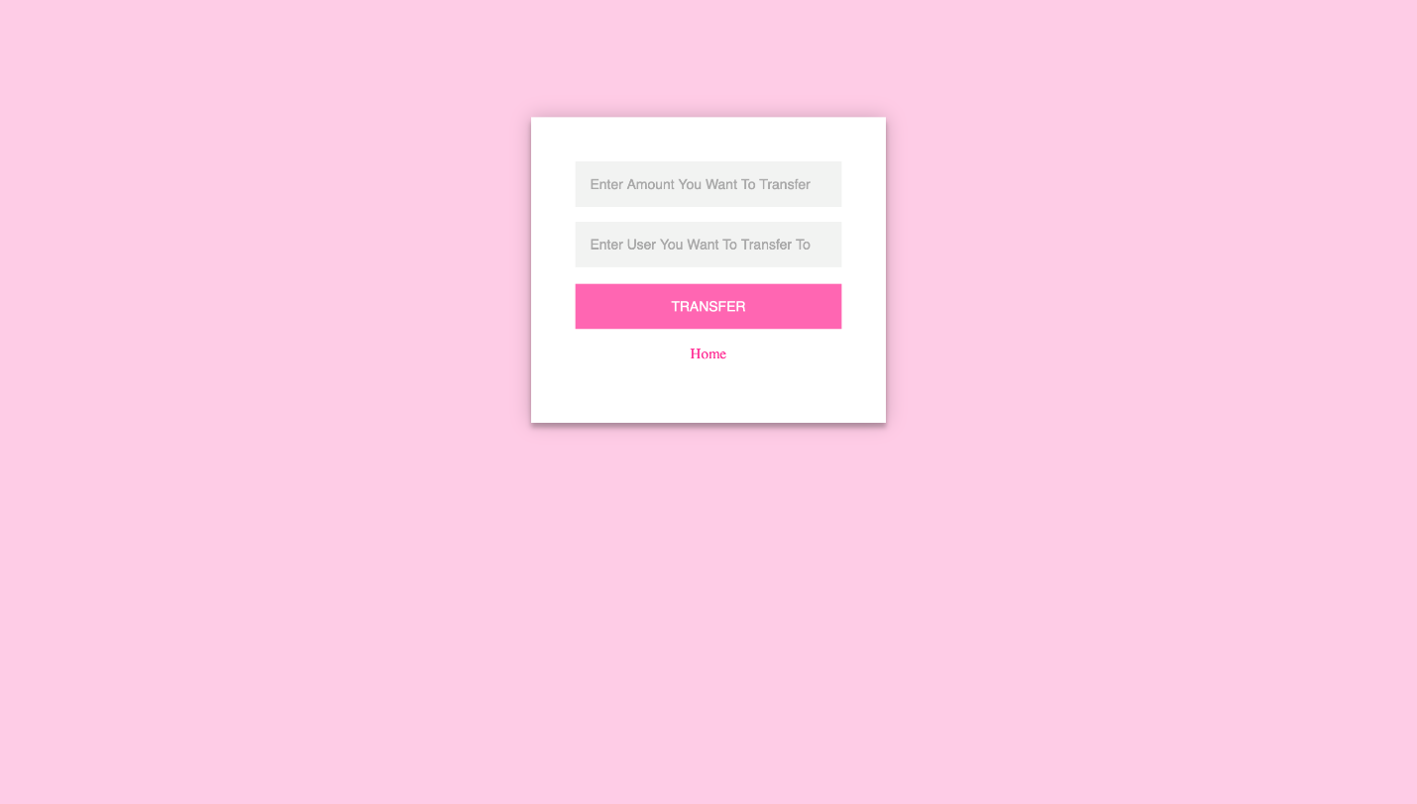

**10-Transaction Confirmation:**

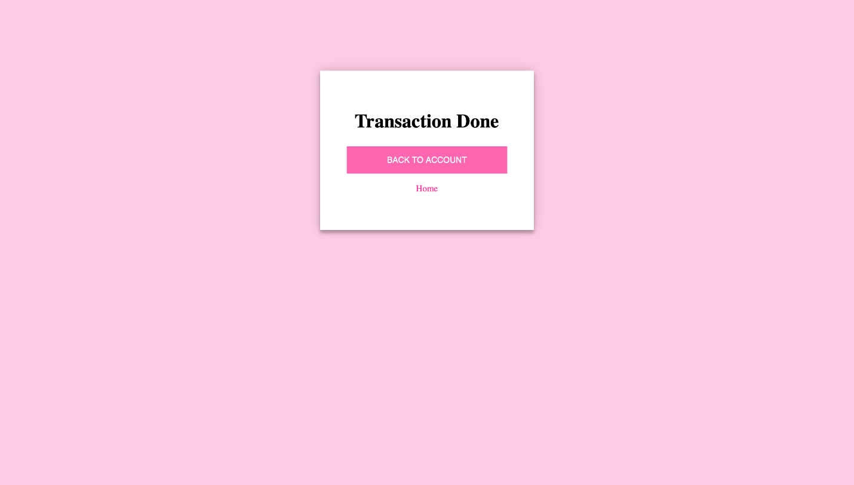

**11-Delete Confirmation:**

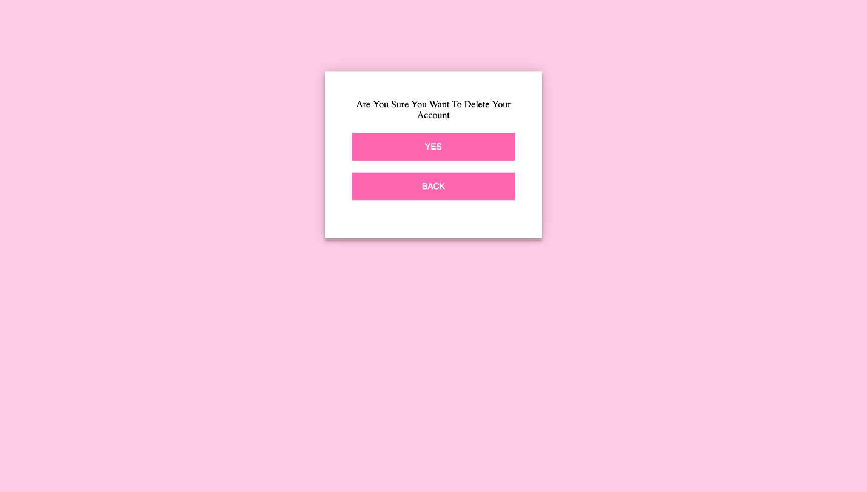

**12-User Deleted:**

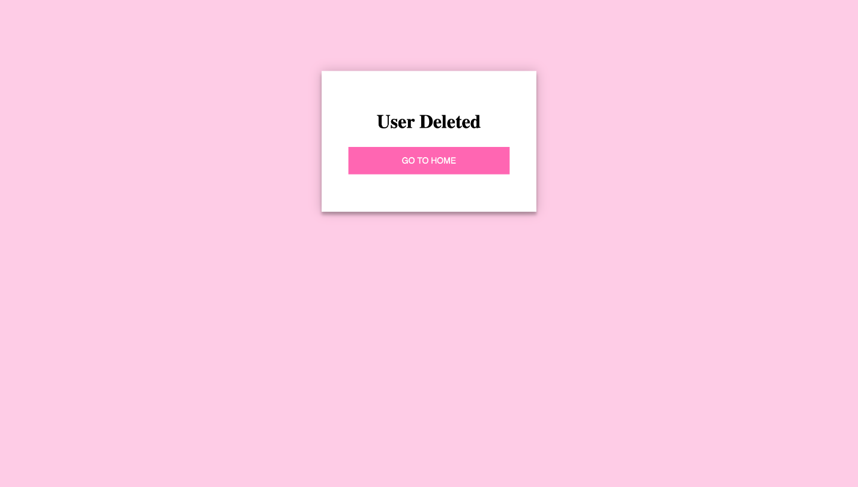

**ERD: -**

